**Maintenance Guide for Jenkins CI**

Purpose: This document guides user on the setup of Automation supporting tools and Jenkins setup and configuration.

Amazon VM Details:

Master(Linux) : <http://ec2-54-158-88-12.compute-1.amazonaws.com>.

|  |  |
| --- | --- |
| Slave (windows): | ec2-54-83-77-194.compute-1.amazonaws.com |
| **User name** | Administrator |
| **Password** | qxNAeHX.o* |

**Amazon Instance login:**

Direct Signin Link: <https://801087532787.signin.aws.amazon.com/console>

User Name: nsen

Password: !#Z(j}z&KuVF

**Jenkins Setup :** we have Jenkins setup in Master and slave model. Master job is configured on Linux machine, whereas Slave is on Windows machine.

**What Jenkins does? Step1** Check out the latest code from Git Repo

Step2 : Build the test-automation projects and then updates the jar and run the

Unit test cases .

Step 3: code coverage tool (cobertura) executes

Step3: Builds the Client project(Amazon POC) and Executes the Test cases

Step 3:Generate Cobertura Report

Step5: Generates HTML report on Test Case Execution

Step 6: mail notification configuration.

Jenkins url: http://ec2-54-158-88-12.compute-1.amazonaws.com/jenkins/job/ETAAP_DEV_CI

Snap shot of Jenkins configuration:

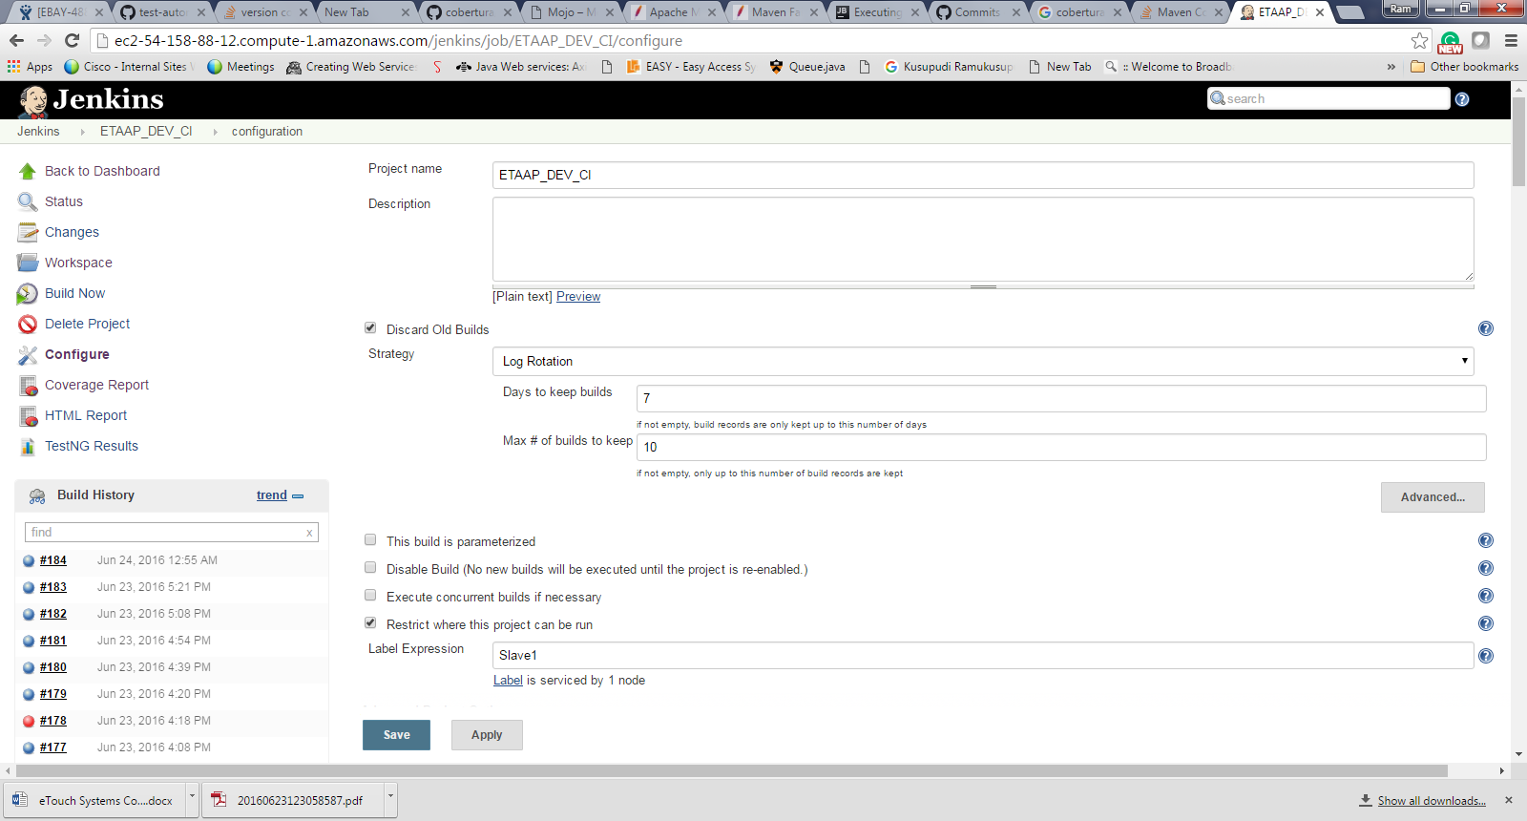

Git repo configuration

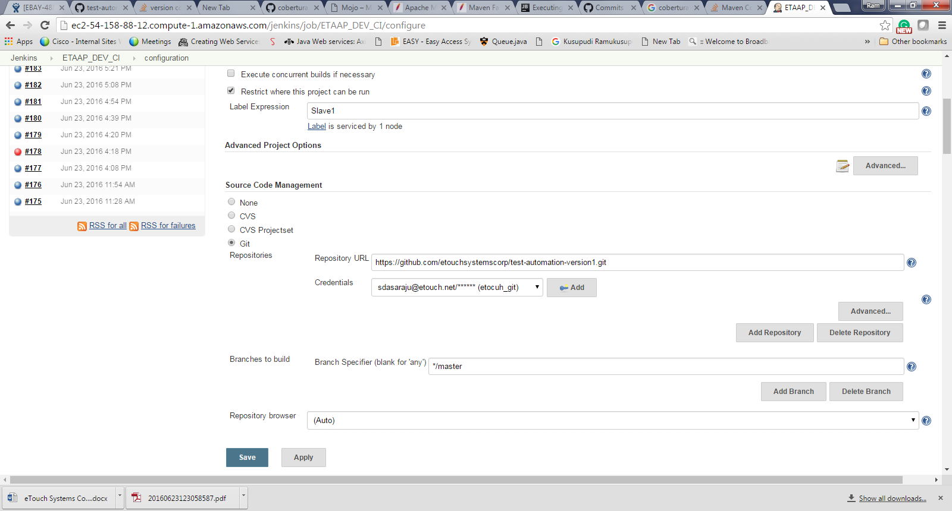

Job run Schedule configuration

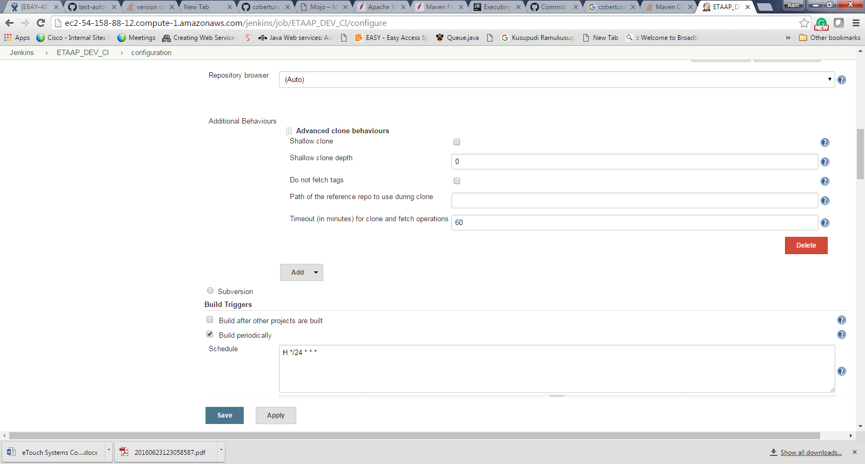

Test-automation library mvn target configuration

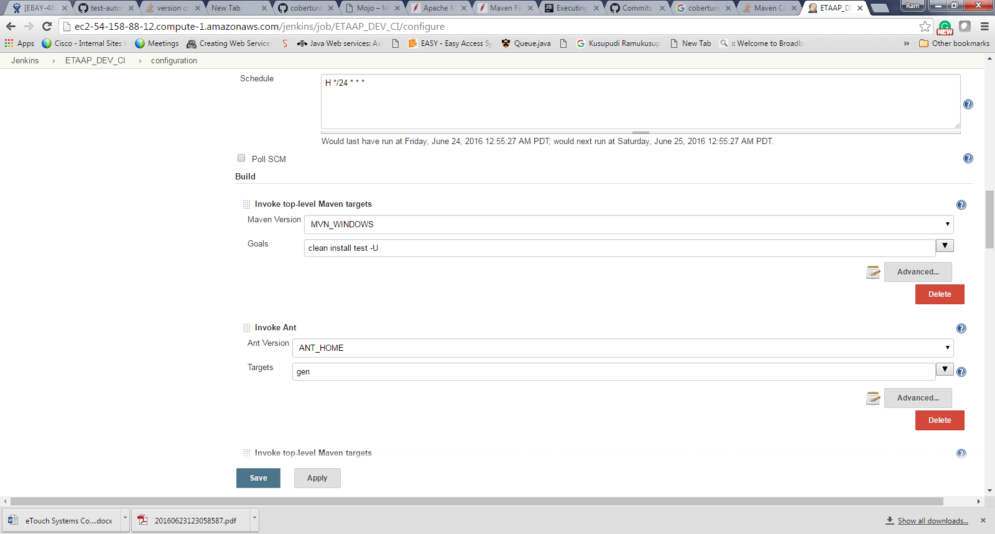

Cobertura mvn target configuration

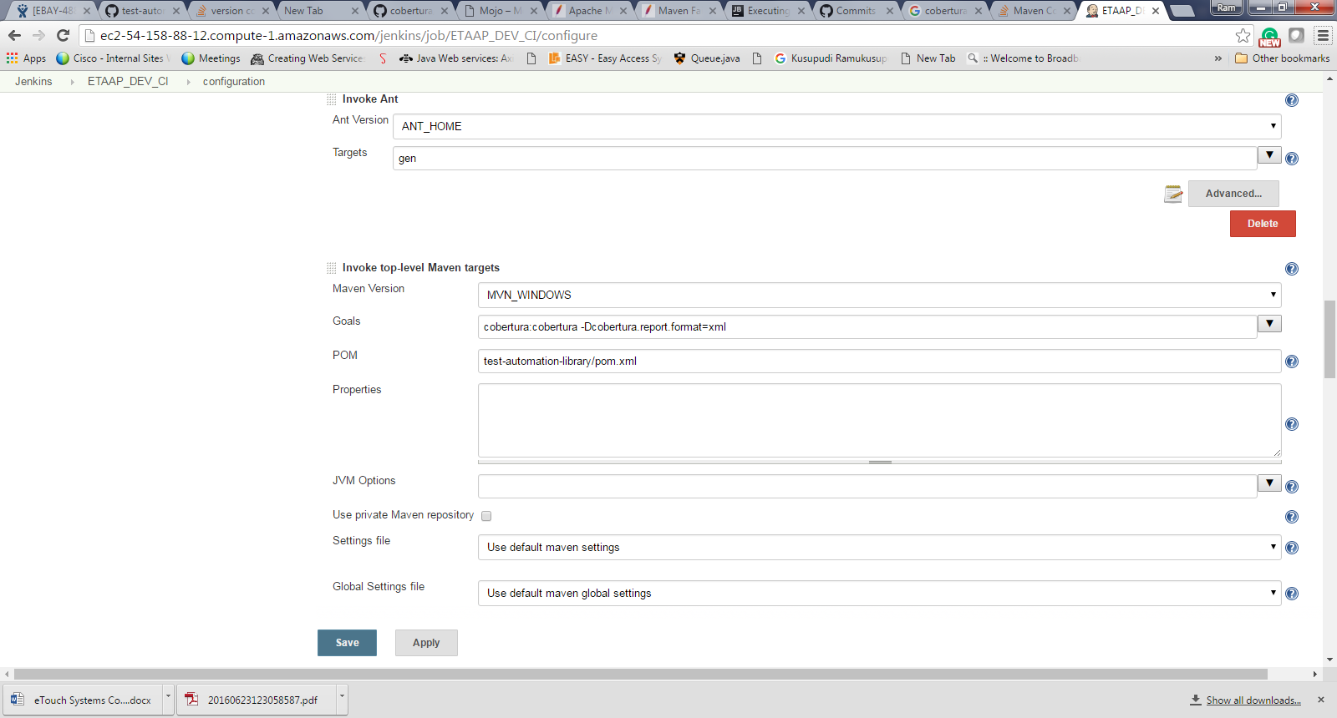

Amazon mvn target configuration

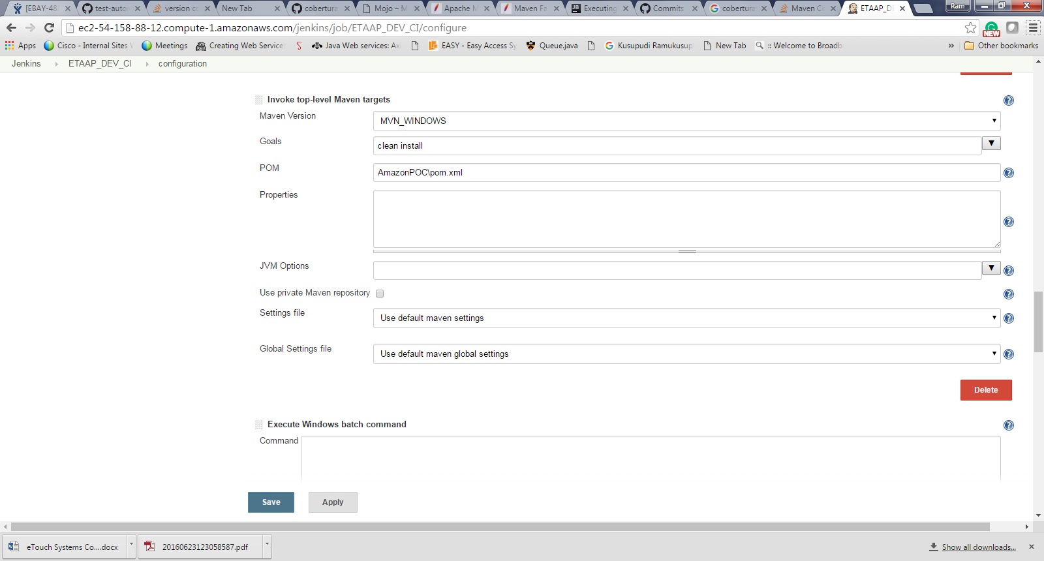

Cobertura Jenkin Plugin configuration

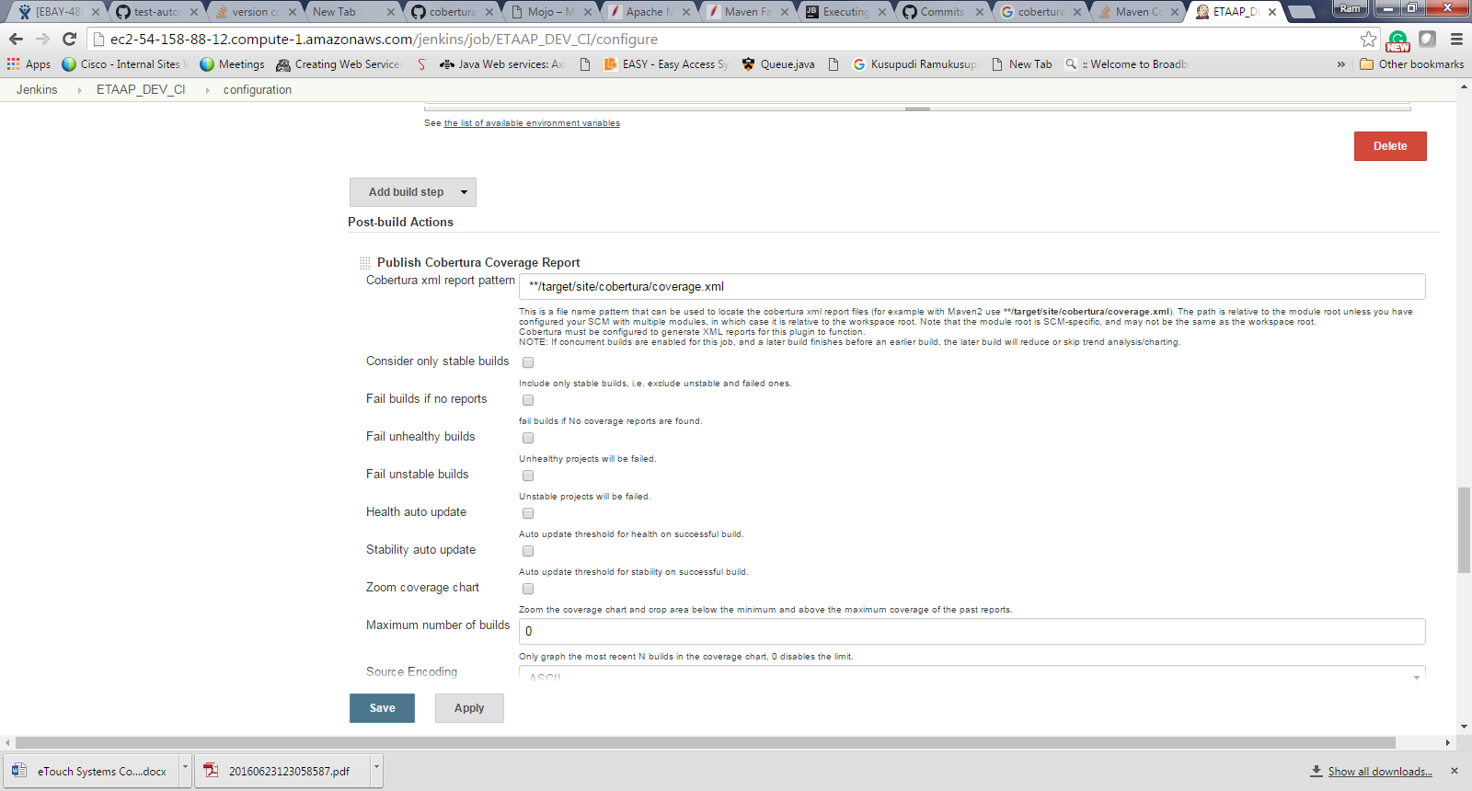

HTML Report plugin configuration

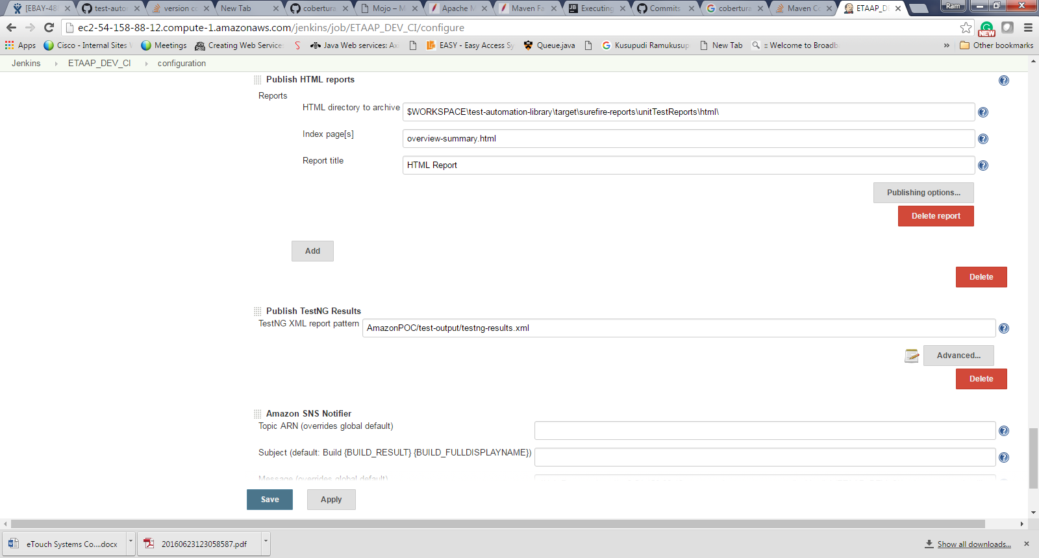

Jenkins Post Built notification configuration.

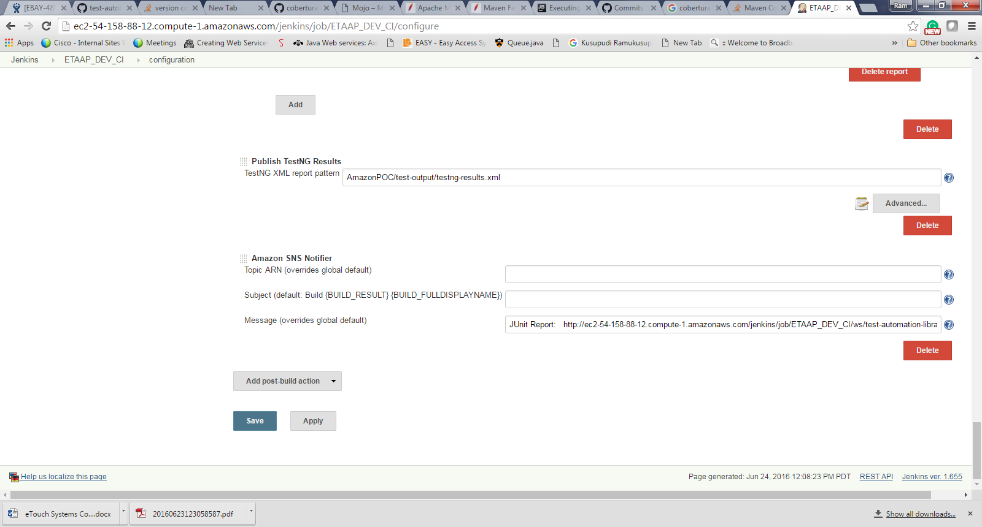

**In case of slave machine shutdown/restart we need to do the following .**

run Jenkins slave jar ( placed on desktop ,can see highlighted with cursor)

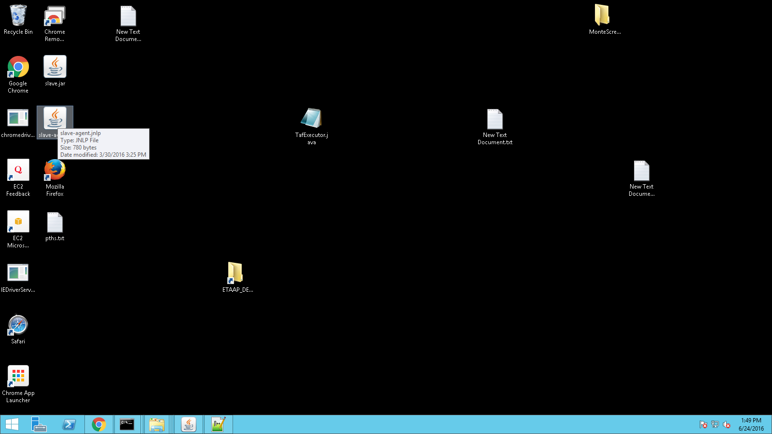

**Run the sonar cube and scanner**

**Step1: Go to Location Z:\sonar-scanner-2.6.1\sonar-scanner-2.6.1\bin then run**

**Sonar-scaner.bat file**

**Step 2 Go to Location :** **Z:\sonarqube-5.5\sonarqube-5.5\bin\windows-x86-64**

**then double click on startsonart.bat( sonar qube should up and running for sonar reports).**

**Note: check sonar is up and running on Localhost:9000**